**Assignment -3**

Python Programming

|  |  |
| --- | --- |
| Assignment Date | 16 October 2022 |
| Student Name | D.Jailakshman |
| Student Roll Number | 953719106302 |
| Maximum Marks | 2 Marks |

**Question-1:**

Image Augumentation

|  |
| --- |
| **Solution:** |
|  |
|  |
|  |
|  |
|  |
|  |
|  |
|  |
|  |
|  |
|  |

**Question-2:**

Create Model

|  |
| --- |
| **Solution:** |

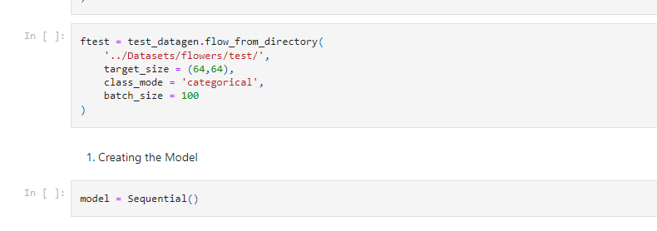

QUESTION -3

Add Layers (Convolution,MaxPooling,Flatten,Dense-(Hidden Layers),Output)

SOLUTION:

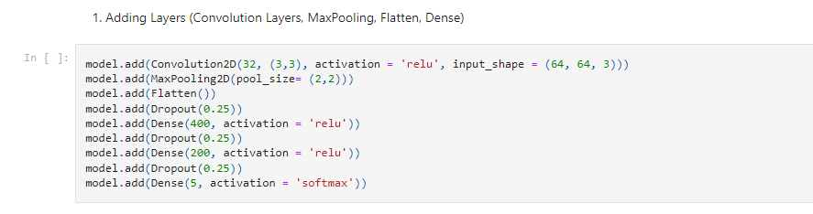

QUESTION-4

Compile ,Fit and save The Model,

SOLUTION:

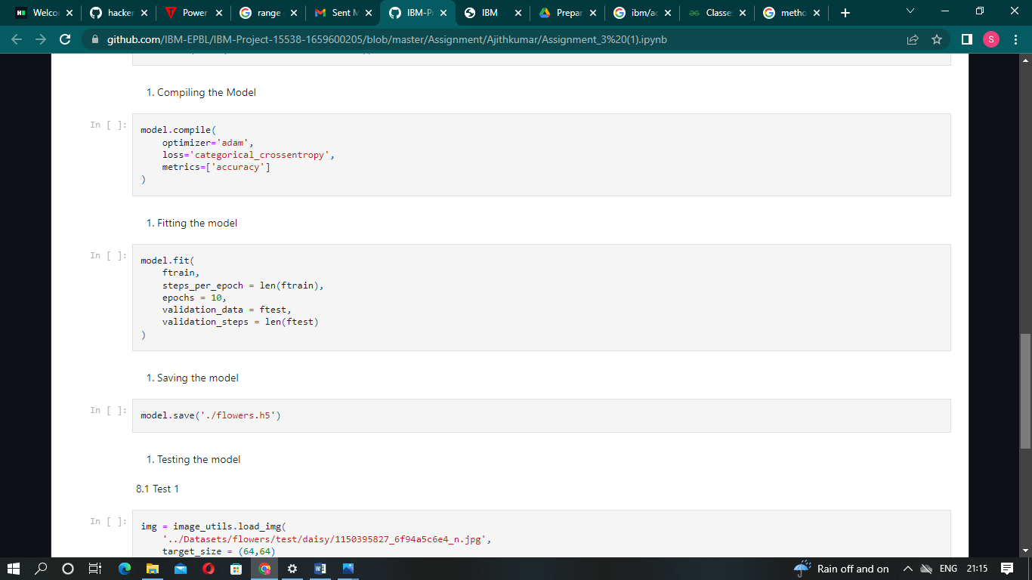

QUESTION -5

Test the model

SOLUTION:

